How to setup the Database on a new PC

1. Download PSQL ODBC from <https://www.postgresql.org/ftp/odbc/versions/msi/>
2. Create a System DSN
   1. Open ODBC Data Sources (32 bit) from windows search bar
   2. Select System DSN at the top
   3. Press add on the right side of the app
   4. Select PostgreSQL Unicode from the popup and press finish
   5. Fill the forms out as follows  
      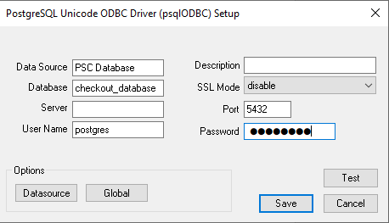  
      Where password is MEpsc154 and server is the IP address of the raspberry pi
   6. Test it and if connection is successful save it
3. In database main page right click on the border of the main screen to see the tab control options and go to the settings tab
4. Change the reminder emails control value on or off and set that value as the default so it stays the same for that computer
5. To get the atrium sales working uninstall any old versions of python, install the newest python version from python.org, and install the selenium software by running the following command in an administrator command prompt  
     
   pip install selenium